CHALLENGES SOLVED

Data Silos Across Formats - Inability to consolidate and analyze data scattered across multiple CSV and Excel files

Static, Non-Interactive Reporting - Traditional charts that don't allow exploration or filtering of underlying data

Complex Setup Requirements - Need for database installation, complex ETL pipelines, and technical infrastructure

Limited Data Agility - Difficulty making quick edits, corrections, or updates to datasets without technical help

Poor Data Discovery - Inability to quickly search across all columns or identify relationships between datasets

High Technical Barrier - BI tools requiring SQL knowledge, programming skills, or extensive training for business users
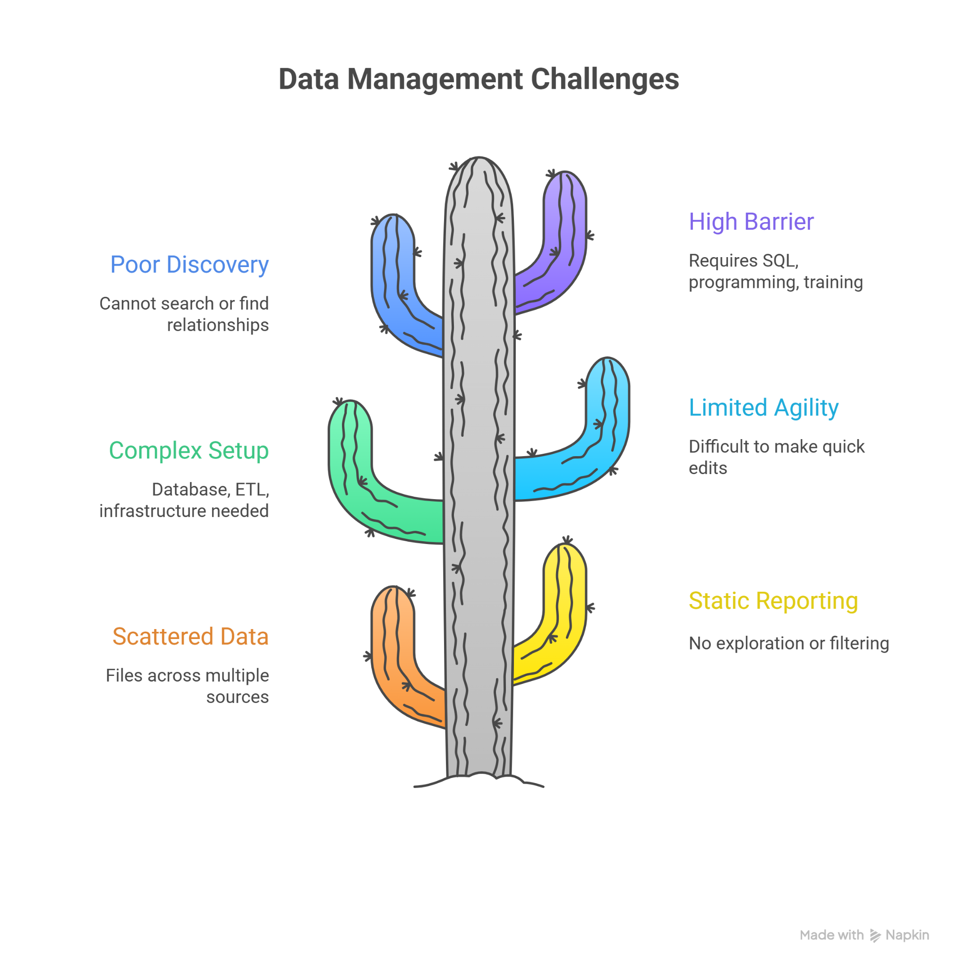

FEATURE HIGHLIGHTS

Dataset Fusion Engine - Automatically merges multiple datasets while intelligently matching similar columns

Interactive Overlap Analyzer - Clickable Venn diagrams that reveal shared companies across data sources with filter-on-click functionality

Smart HQ Mapper - Dynamic distribution charts that switch between views and use NLP to detect countries from headquarters text

Live Table Editor - In-cell editing with instant validation that syncs changes to both the unified view and original datasets

Universal Search Portal - Fuzzy and exact searching across all data columns with column-specific filtering capabilities

One-Click Deployment - Zero-database architecture that runs with a single Python command and works in any modern browser
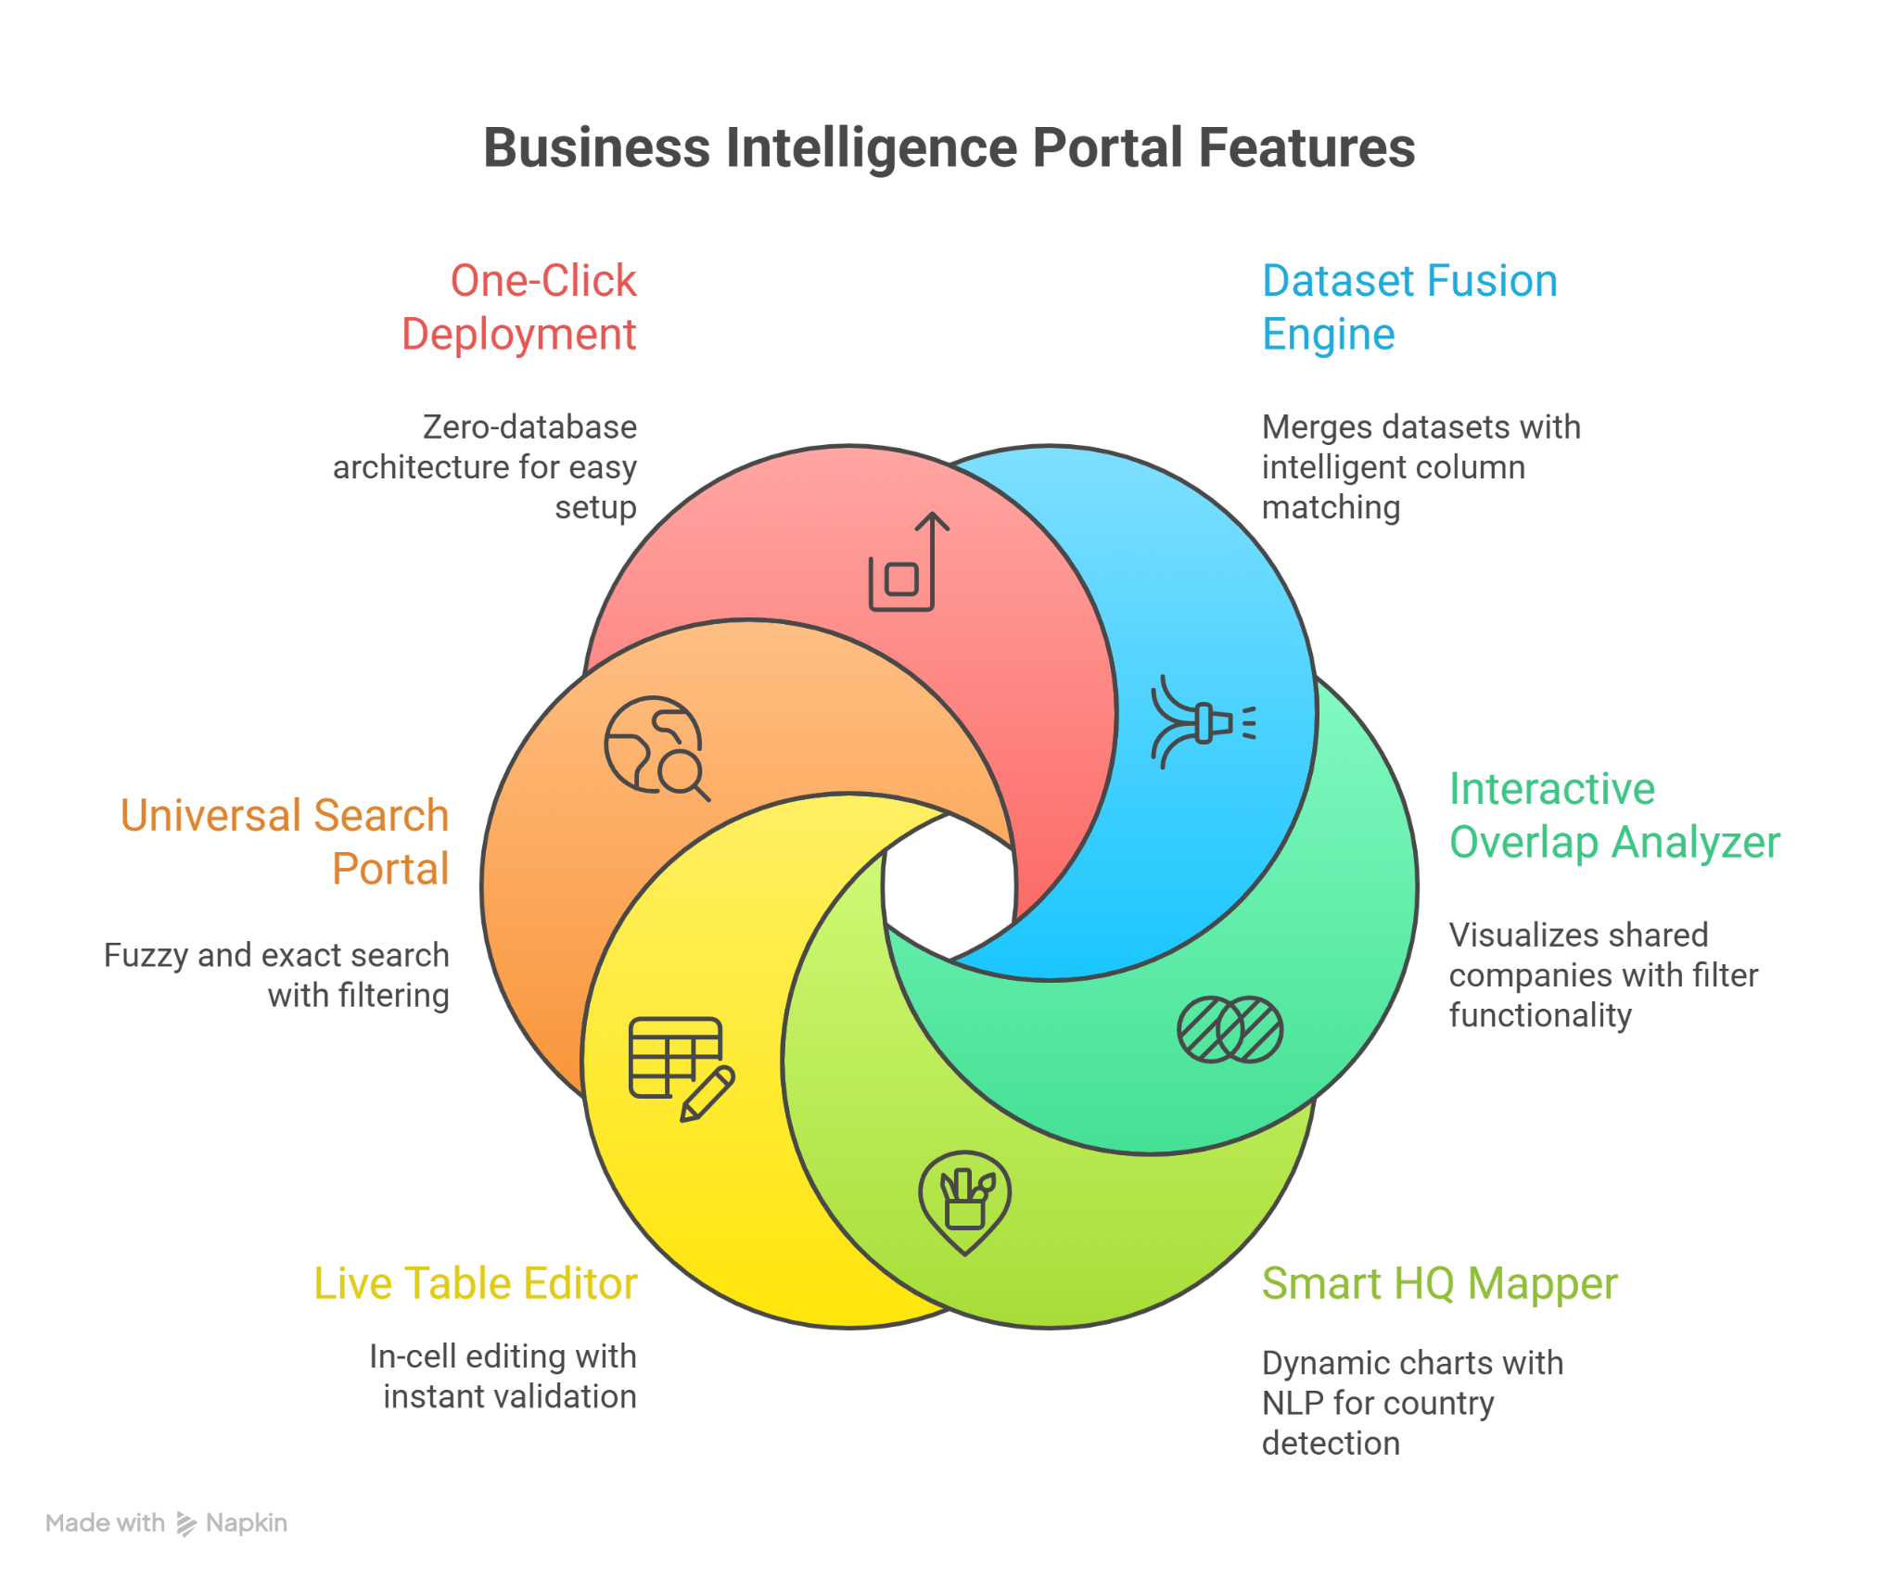

KEY BENEFITS

Time Compression - Reduces data preparation time from hours to minutes through automated consolidation

Discovery Empowerment - Turns passive viewers into active explorers with clickable, filterable visualizations

Infrastructure Freedom - Eliminates database setup and maintenance while enabling immediate deployment

Data Agility - Enables real-time corrections and updates that immediately propagate through all views

Insight Acceleration - Uncovers hidden relationships and patterns through interactive overlap analysis

Democratized Analytics - Makes advanced BI capabilities accessible to non-technical business users without training

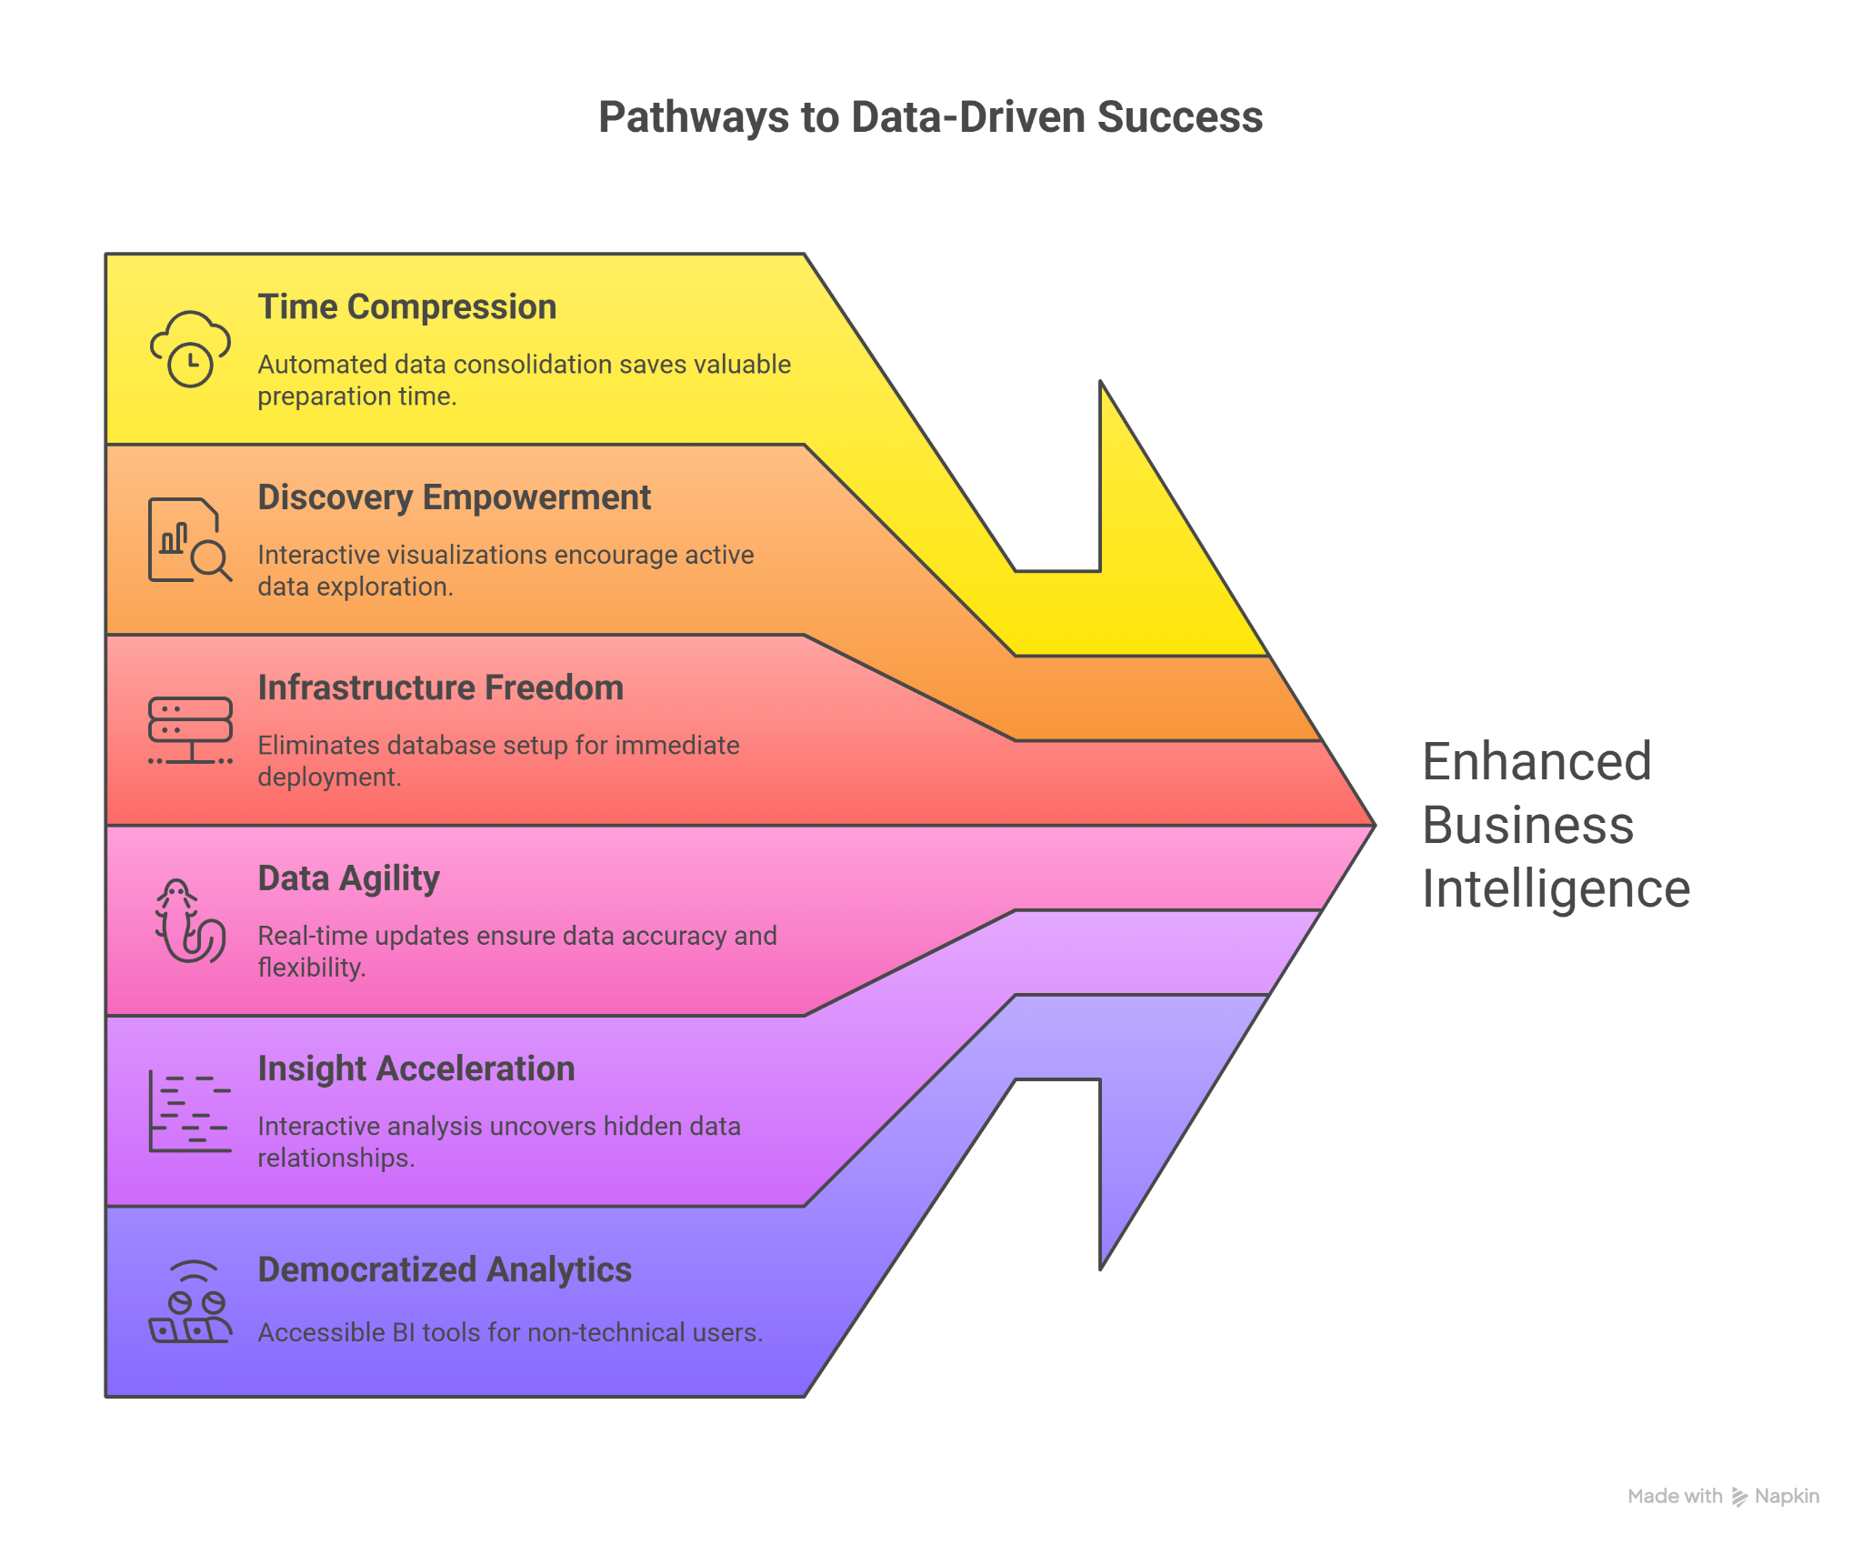

SUMMARY

The Business Intelligence Portal is a comprehensive, no-database web application that transforms raw, multi-source data into actionable insights through intelligent aggregation, real-time editing, and advanced interactive visualizations, enabling seamless data exploration and management directly from a user's browser with a simple Flask backend.

Report and software prepared by: Dirshak Deepak Patro
Position: Operators and Enterprise Intern, Digital Infrastructure

